The Story of Netflix

Tim Brackett, Daniel Chia, Jim Bruning

Outline: Analyze Netflix over a variety of metrics. We will then look through important dates in the company history and analyze the stock price post those dates. We would try to find a correlation / relationship between key historical dates for Netflix and how long it takes for the stock price to be affected either negatively or positively. Utilize geographic data to see across the globe when Netflix was introduced over each region. How much content has grown and changed by year / month in each market and the growth of the international scene.

Data Sets: <https://www.kaggle.com/akpmpr/updated-netflix-stock-price-all-time>

<https://www.kaggle.com/pariaagharabi/netflix2020/metadata>

<https://www.kaggle.com/shivamb/netflix-shows>

Visualization Idea

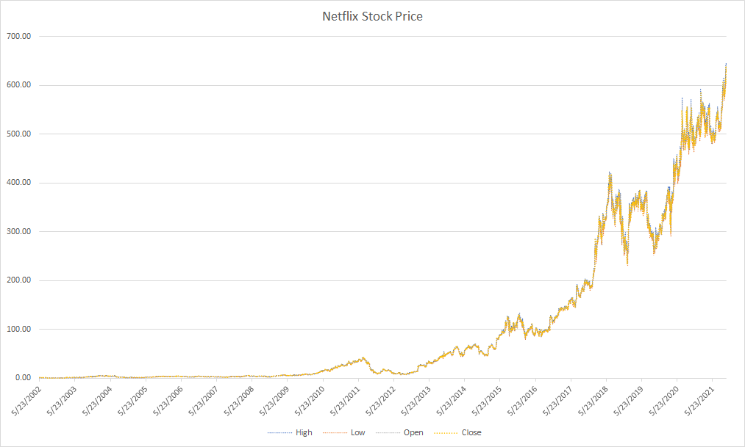

Have the visualization be filterable so you can get specific years for the data

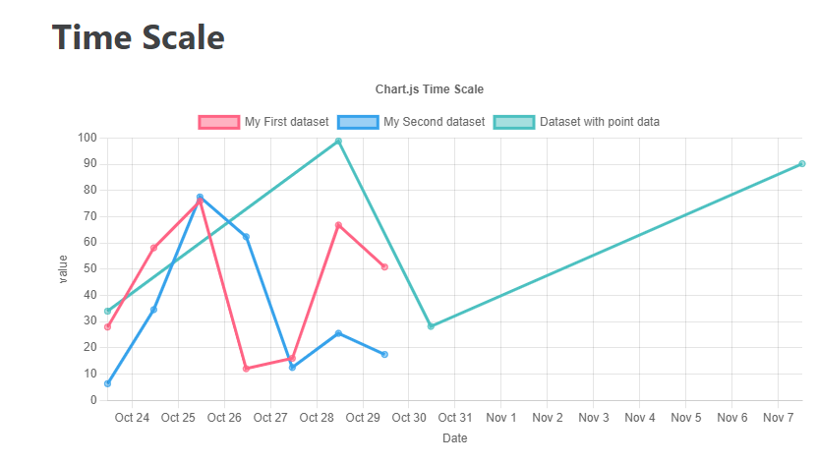

Towards the end of the presentation, we would like to show the price of Netflix’s stock price changes compared to competitors stock prices in the same timeframe. This might help demonstrate if competitors had an effect on Netflix’s stock price overall.

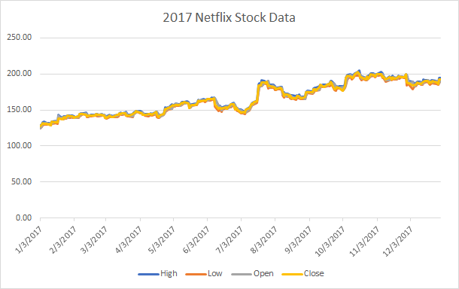

Examples of Visualizations that Inspired Us:

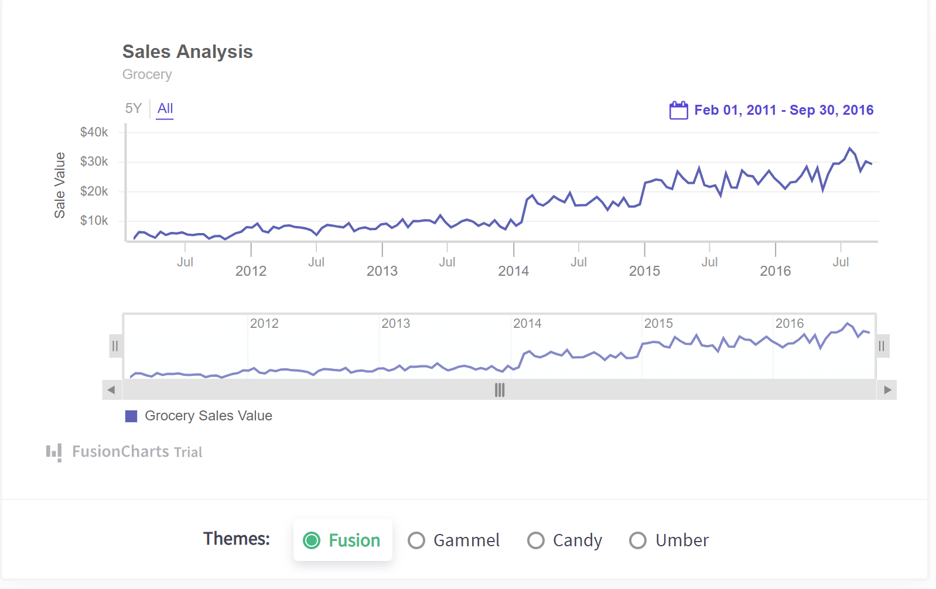

(we would like to make use of slider functionality and being able to pick a subset for dates [doing a 1 year or 6 month trend vs the whole data set])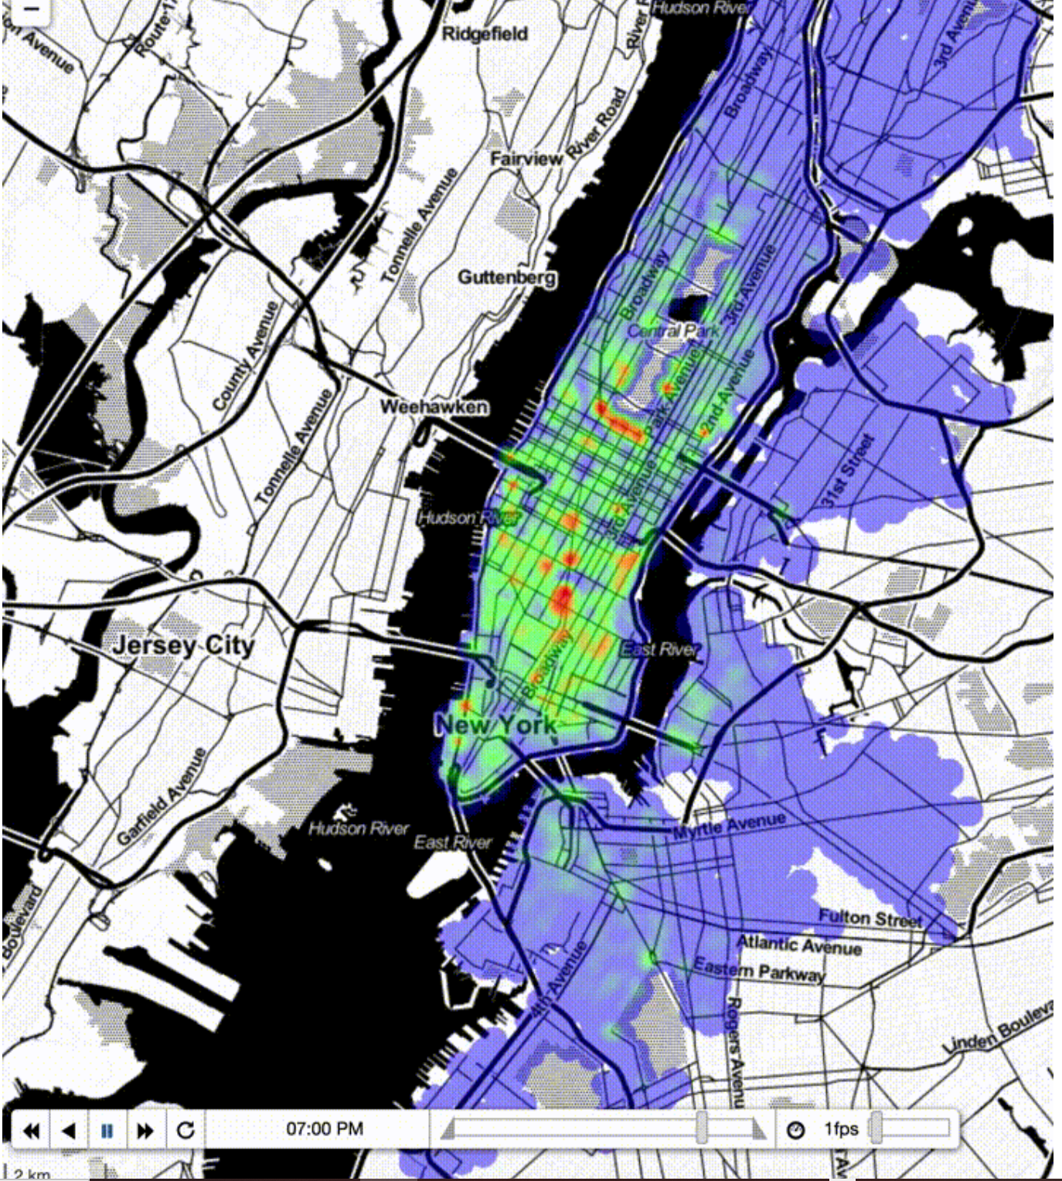

(context to picture, we would hope to create a time lapse heatmap of Netflix as they grow in international markets as a world map). Below is a current map of Netflix’s international availability from Netflix’s website that inspired this idea.

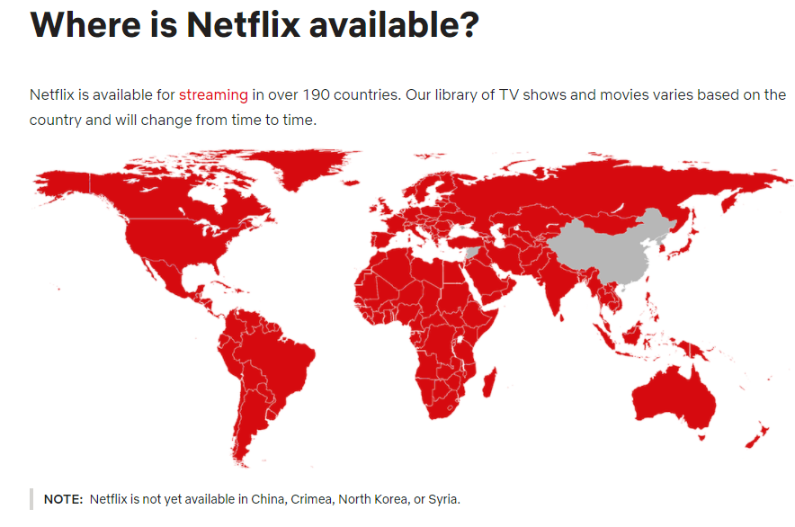

Github Repository: <https://github.com/jabrunin001/Project-2.git>